Architectural Factors

* Performance/ Accuracy
* TeeTime Membership levels

Software Architecture Document

* Architectural Representation
* Architectural factors are described using a factor table

Includes the following:

* Factor
* Measures and quality scenarios
* Variability (current flexibility and future evolution)
* Impact of factor (and its variability) on stakeholders, architecture, and other factors
* Priority for success
* Difficulty or risk
* Architectural decisions are described using a technical memo

Includes the following:

* Issue
* Solution summary
* Factors resolved
* Solution
* Motivation
* Unresolved issues
* Alternatives considered
* Architectural views are used to provide perspectives that emphasize key and noteworthy information, ideas, and motivations
* Use Case View
* Logical View
* Data View
* Implementation View
* Deployment View
* Business Case
* Business Bid
* Project plan
  + Phase Plan
  + Project Schedule
* Architectural Factor
* Performance/ Accuracy
* Tee Time Membership levels

Performance/Accuracy for TeeTime Membership levels should be high because of the high business value.

* Software Architecture Document
* Architectural Representation
* See supplementary specification
* Architectural factors

|  |  |  |  |  |  |  |
| --- | --- | --- | --- | --- | --- | --- |
| **Category/ Subcategory** | **Factor** | **Measures** | **Variability** | **Impact of factors** | **Priority of Success** | **Risk** |
| Performance/ Accuracy | Tee time membership levels | Gold- Anytime  Silver-  Mon-Fri  (Before 3 p.m., after 5:30 p.m.)  Weekend/Holiday  (after 11 a.m.)  Bronze-  Mon-Fri  (Before 3 p.m., after 6 p.m.)  Weekend/Holiday  (after 1 p.m.) | * Current flexibility (levels- gold, silver, bronze) * Future evolution/ expand | On Stakeholders, Players, Clerk, Pro-shop staff, Membership Committee | High | Critical |

* Architectural decisions

Technical Memo

Issue: Scheduling tee time for membership levels

Solution Summary: Using Identity Framework

Factors: Tee Time Membership Levels

Solutions: Identity Framework will be used for Membership levels and they can login and access into their accounts or book their tee times. In future, if there will be any additions in the Membership levels, levels can be added easily by adding any number of users and giving access to those through login user id and password.

There will not be any other major modifications that need to be made in the system and which will prevent breaking in other parts of the system. System will perform as usual.

Motivation: Using Identity framework will allow expanding membership level to be much simpler and easier.

Unresolved Issues: N/A

Alternatives considered: The other alternative may be that we could have created separate table for Membership levels and Types and if there would be needed to add more levels, we just had to insert new row into the table.

* Use Case View

Architecturally significant use cases

* Books Tee Time
* Submit Standing Tee Time

Discussion and Motivation

BooksTeeTime

The purpose of this use-case is to allow players, clerks and pro-shop staff to book tee times.

Different levels of player can book at different times.

Can be done:

By Players- Gold, Silver and Bronze through online website 1 week in advance,

By Clerk on phone, 1 week in advance,

By Pro-shop staff in person or by phone, the same day golf is played.

SubmitStandingTeeTimeRequest

The purpose of this use case is to allow shareholder members to make standing tee time requests.

Data View

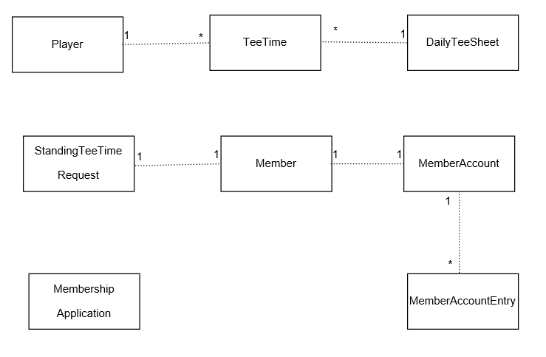

Discussion and Motivation

Player can book multiple tee time, that means any Player can appear multiple time in Tee Time table but that Player has to have in Player table first. Daily Tee Sheet has Date which acts as a primary key in Daily Tee Sheet and acts as a Foreign Key in Tee Time table, means date in Daily Tee Sheet table can appear multiple times in TeeTime table but has to have in Daily TeeSheet Table.

Any Shareholder member can submit one standing tee time request, this why the relationship between Member and StandingTeeTimeRequest is one to one. Each member is associated with one MemberAccount and so, relationship is one to one, and MemberAccount is associated with MemberAccountEntry. There can be multiple account entries for each member account, so relationship is one to many. Any person can fill Membership Application.

Logical View

Layer Diagram

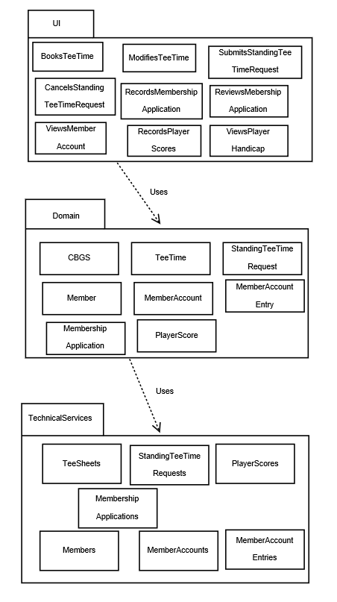

Discussion and Motivation

There are three layers i.e. UI Layer, Domain Layer and Technical Services Layer. UI Layer which contains all the pages that appears as the User Interface comes under UI Layer. These are basically razor pages. So, here we have Razor pages or forms that appears to the users and users can BookTeeTime, ModifyTeeTime, SubmitStandingTeeTimeRequest, CancelStandingTeeTimeRequest, RecordsMembershipApplication, ReviewsMembershipApplication, ViewsMemberAccount, RecordsPlayerScores and ViewsPlayerHandicap. This layer interacts with the Domain layer which contains the classes such as TeeTime, SubmitStandingTeeTimeRequest, Member, MembershipApplication, MemberAccount, MemberAccountEntry, PlayerScore and CBGS. UI Layer uses classes in Domain Layer and passes request to the Domain layer which then uses classes in Technical Services Layer. Technical Services layer contains classes which are used to call the procedures that are required.

Design Class Diagram

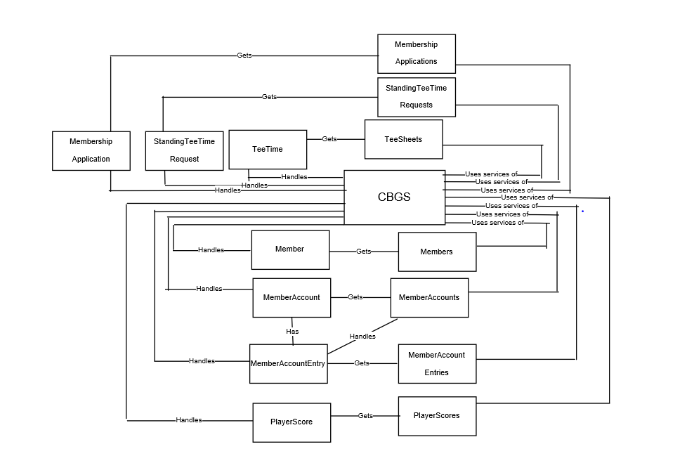

Discussion and Motivation

CBGS Class acts as the RequestDirector which uses services of TeeSheets gets TeeTime and Handles TeeTime to the CBGS or uses services of StandingTeeTimeRequests to get StandingTeeTimeRequest and handles it to CBGS or uses services of MembershipApplications or gets MembershipApplication and hanles it to CBGS or uses services of Members, gets Member and handles it to CBGS or uses services of MemberAccounts or gets MemberAccounts and handles MemberAccounts and MemberAccountEntries to CBGS or uses services of PlayerScores gets PlayerScore and handles PlayerScore to CBGS.

Implementation View

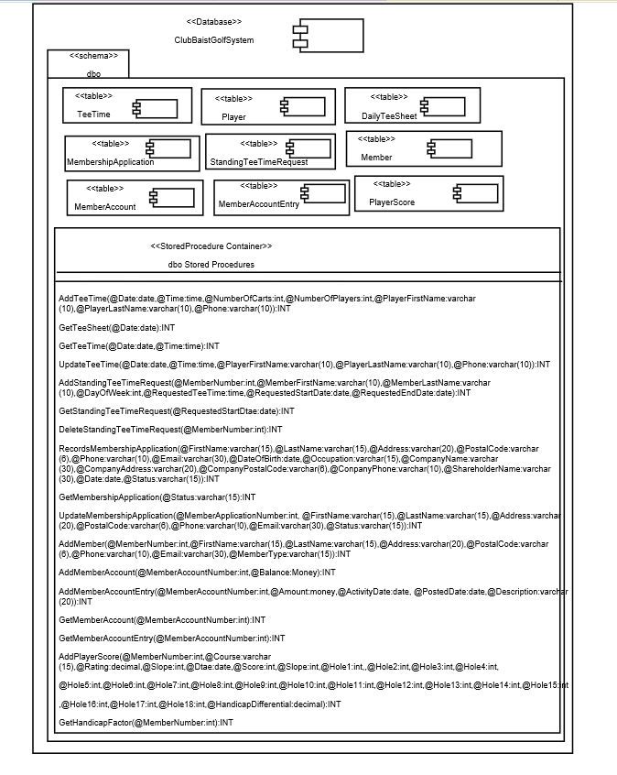

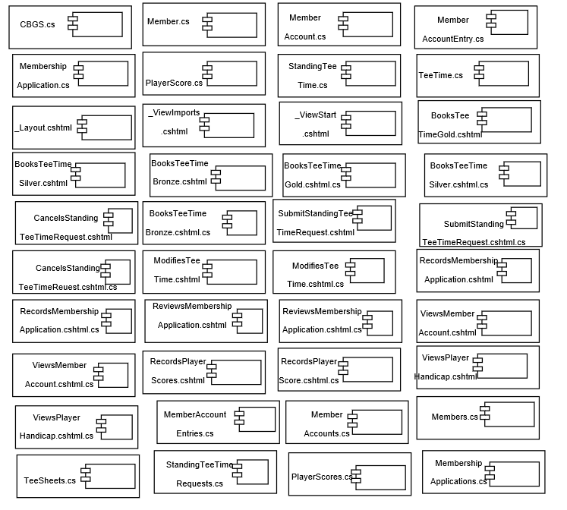

Discussion and Motivation

There is a database component. I have created database ClubBaistGolfSystem. Schema used is dbo. Then there are table components. Each table component is the table that is created such as DailyTeeSheet, Player, TeeTime, StandingTeeTimeRequest, MembershipApplication, Member, MemberAccount, MemberAccountEntry, PlayerScore. There is a stored procedure container which contains all the stored procedure required to BookTeeTime, ModifyTeeTime, SubmitStandingTeeTimeRequest, CancelsStandingTeeTimeRequest, RecordsMembershipApplication, ReviewsMembershipApplication, ViewsMemberAccount, RecordsPlayerScores and ViewsPlayerHandicap. Below I have all the file component. Each file component is the file I have created. These are the razor pages which contains all the files with .cshtml extension and .cshtml.cs extension and also it contains files with .cs extension that are the classes

Deployment View

Architecturally significant nodes and physical configuration between node

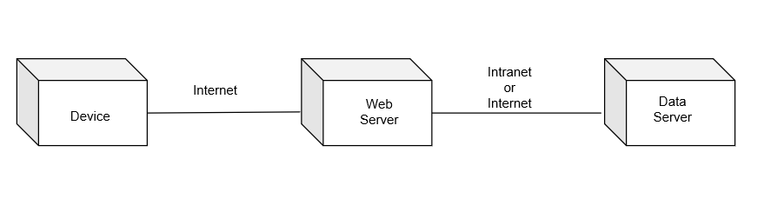

* Discussion and Motivation

Device- It is the device that is used by the Player, Clerk, Pro-shop staff.

Hardware- PC, Mobile, Tablet

Software- Web Browser

* Web Server

Hardware- Web Server

Software- Web Hosting Server (WebBaist)

* Data Server

Hardware- Data Server (DataBaist)

For submitting request such as BookTeeTime, ModifyTeeTime Player, or Clerk or Proshop staff from his device submits request to the system. For request such as ViewsPlayerHandicap, player and clerk from his device submits request to the system, for RecordsPlayerScores, player submits the request to the system from his device, for ViewsMemberAccount, Member submits request to the system from his device, for SubmitsStandingTeeTimeRequest and CancelsStandingTeeTimeRequest, ShareholderMember submits request to the system from his device, for ReviewsMembershipApplication and RecordsMembershipApplication MembershipCommittee submits request to the system from its device, which then passes to the web server through http. Web Server then processes the request and forwards it to the Data Server and the via-versa.

* **Business Case**
* Business Bid

Website is developed for internal use for the Golf Club Baist.

Economic gains to the Club Baist by developing this Project:

|  |  |
| --- | --- |
| Board of Directors | Will get benefit because BooksTeeTime has the high business value |
| Members | Get a website to allow them to book/ cancel TeeTimes online |
| Clerk | Will also be able to book/ cancel or make any modification in TeeTimes on behalf of Players |
| Proshop Staff | Can also book/ cancel/ modify TeeTimes on behalf of players |
| Shareholder Members | Can submit StandingTeeTimeRequests online |